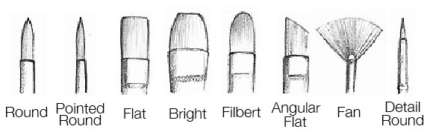
There are 8 main types of artist paint brushes that are used with acrylics, shown above. Each one is specially intended for different uses. Before we get into the particular uses of each paintbrush, let's get a quick low-down of the different parts of the brush:

Get to know your paintbrush
A paintbrush is made of 4 main parts:
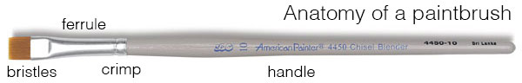

- bristles - also known as hairs. can be natural, synthetic, or combination of both
- ferrule - the silvery bit that connects the bristles with the handle
- crimp - the part of the ferrule that secures it to the handle
- handle - usually made of wood or acrylic
Easy enough! So now that you know the lingo, let's find out what each brush is meant for!

Acrylic Paint Brushes
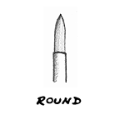
Round or pointed tip.
Good for: sketching, outlining, detailed work, controlled washes, filling in small areas. creates thin to thick lines - thin at the tip, becoming wider the more its pressed down.. use with thinned paint rather than thick paint.
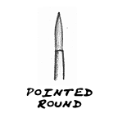
Narrower than the round paintbrush. has sharply pointed tip.
Good for: fine details and lines, delicate areas, spotting and retouching.
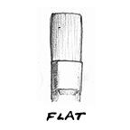
Square end, with medium to long hairs.
Good for: bold strokes, washes, filling wide spaces, impasto. can use edge for fine lines, straight edges and stripes. long haired flat brushes are ideal for varnishing.
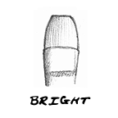
Flat with edges curved inward at tip, with shortish hairs.
Good for: short controlled strokes. thick, heavy color. better for working up close rather than holding the brush at a distance from the canvas.
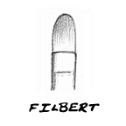
Flat and oval-shaped end with medium to long hairs.
Good for: blending, soft rounded edges like flower petals. this brush is sort of a combination of the rounds (because they can be used for detail) and flat (because they can cover more space than round).
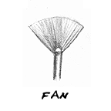
Flat, spread hairs.
good for: natural hairs are good for smoothing, blending, and feathering. synthetic hairs are better for textural effects, clouds, and leaves on trees. for acrylics, use strong and sturdy one, otherwise the hairs will clump when paint is added.
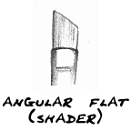
Flat with angled hairs at end.
Good for: curved strokes and filling corners. can reach small areas with tip. also can be used to cover lots of space, similar to flat brushes.
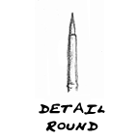
Round, hairs shorter in length. shorter handle.
Good for: details and short strokes. holds more color than you might think!

Types of Brushes
- Natural-bristle brushes made with animal hairs are used for applying oil base paints, varnishes, shellac, polyurethane and other oil base finishes. The natural "flagging" (splitting or fuzzy tips) of these brushes creates split ends in the bristles that hold more paint and help assure a smooth paint release and finish.
- Blended nylon/polyester brushes are easy to clean and work well with all types of latex paints. The combination of nylon's durability and polyester's shape retention is the mark of a high-quality brush - one that also produces a high-quality paint finish. What's more, these durable brushes are built to handle numerous projects. So, with proper care, nylon / polyester brushes should last for years.
- Polyester brushes are best for latex paints. These brushes hold their shape and stiffness in any paint and apply paint smoothly and evenly.
Brush Sizes
Sherwin-Williams paintbrushes are available in widths from 1 to 4 inches. The size you select is up to you, but a good rule of thumb is:
- 1" to 2" – window and other small trim
- 3" – glossy paints for doors and cabinets
- 4" – large, flat areas
Brush End Types
- Chisel Trim Brush - slanted bristles produce a good, straight line for trimming in corners and edges.
- Square Trim Brush - the ends of the bristles are cut square and used primarily for applying paint over flat areas.
- Angled Brush - bristles are cut to make it easier to apply paint to window trim.
Brush Styles
- Thin Angle Sash - slanted bristles and a thin profile produce a good, straight line for trimming in corners and edges.
- Angle Sash - features slanted bristles and holds more paint than its thin counterpart. Excellent for cutting in at the ceiling or painting trim.
- Flat Sash - bristles are straight across and used primarily for applying paint over flat areas.
- Trim - a flat brush excellent for painting large flat surfaces, especially exterior siding.
- Wall - a thick flat brush that holds a larger amount of paint. Excellent for painting larger surface areas.

