Image Research
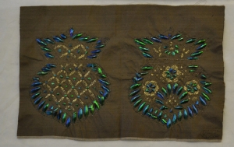
https://trc-leiden.nl/trc-needles/techniques/applied/beetlewing-embroidery

The above image is beetle wing embroidery, which became prominent in Western fashion in the late 17th, early 18th century, but originated in Southeastern Asia. The wing casings of the Sternocera beetle are sewn onto a garment in various patterns.

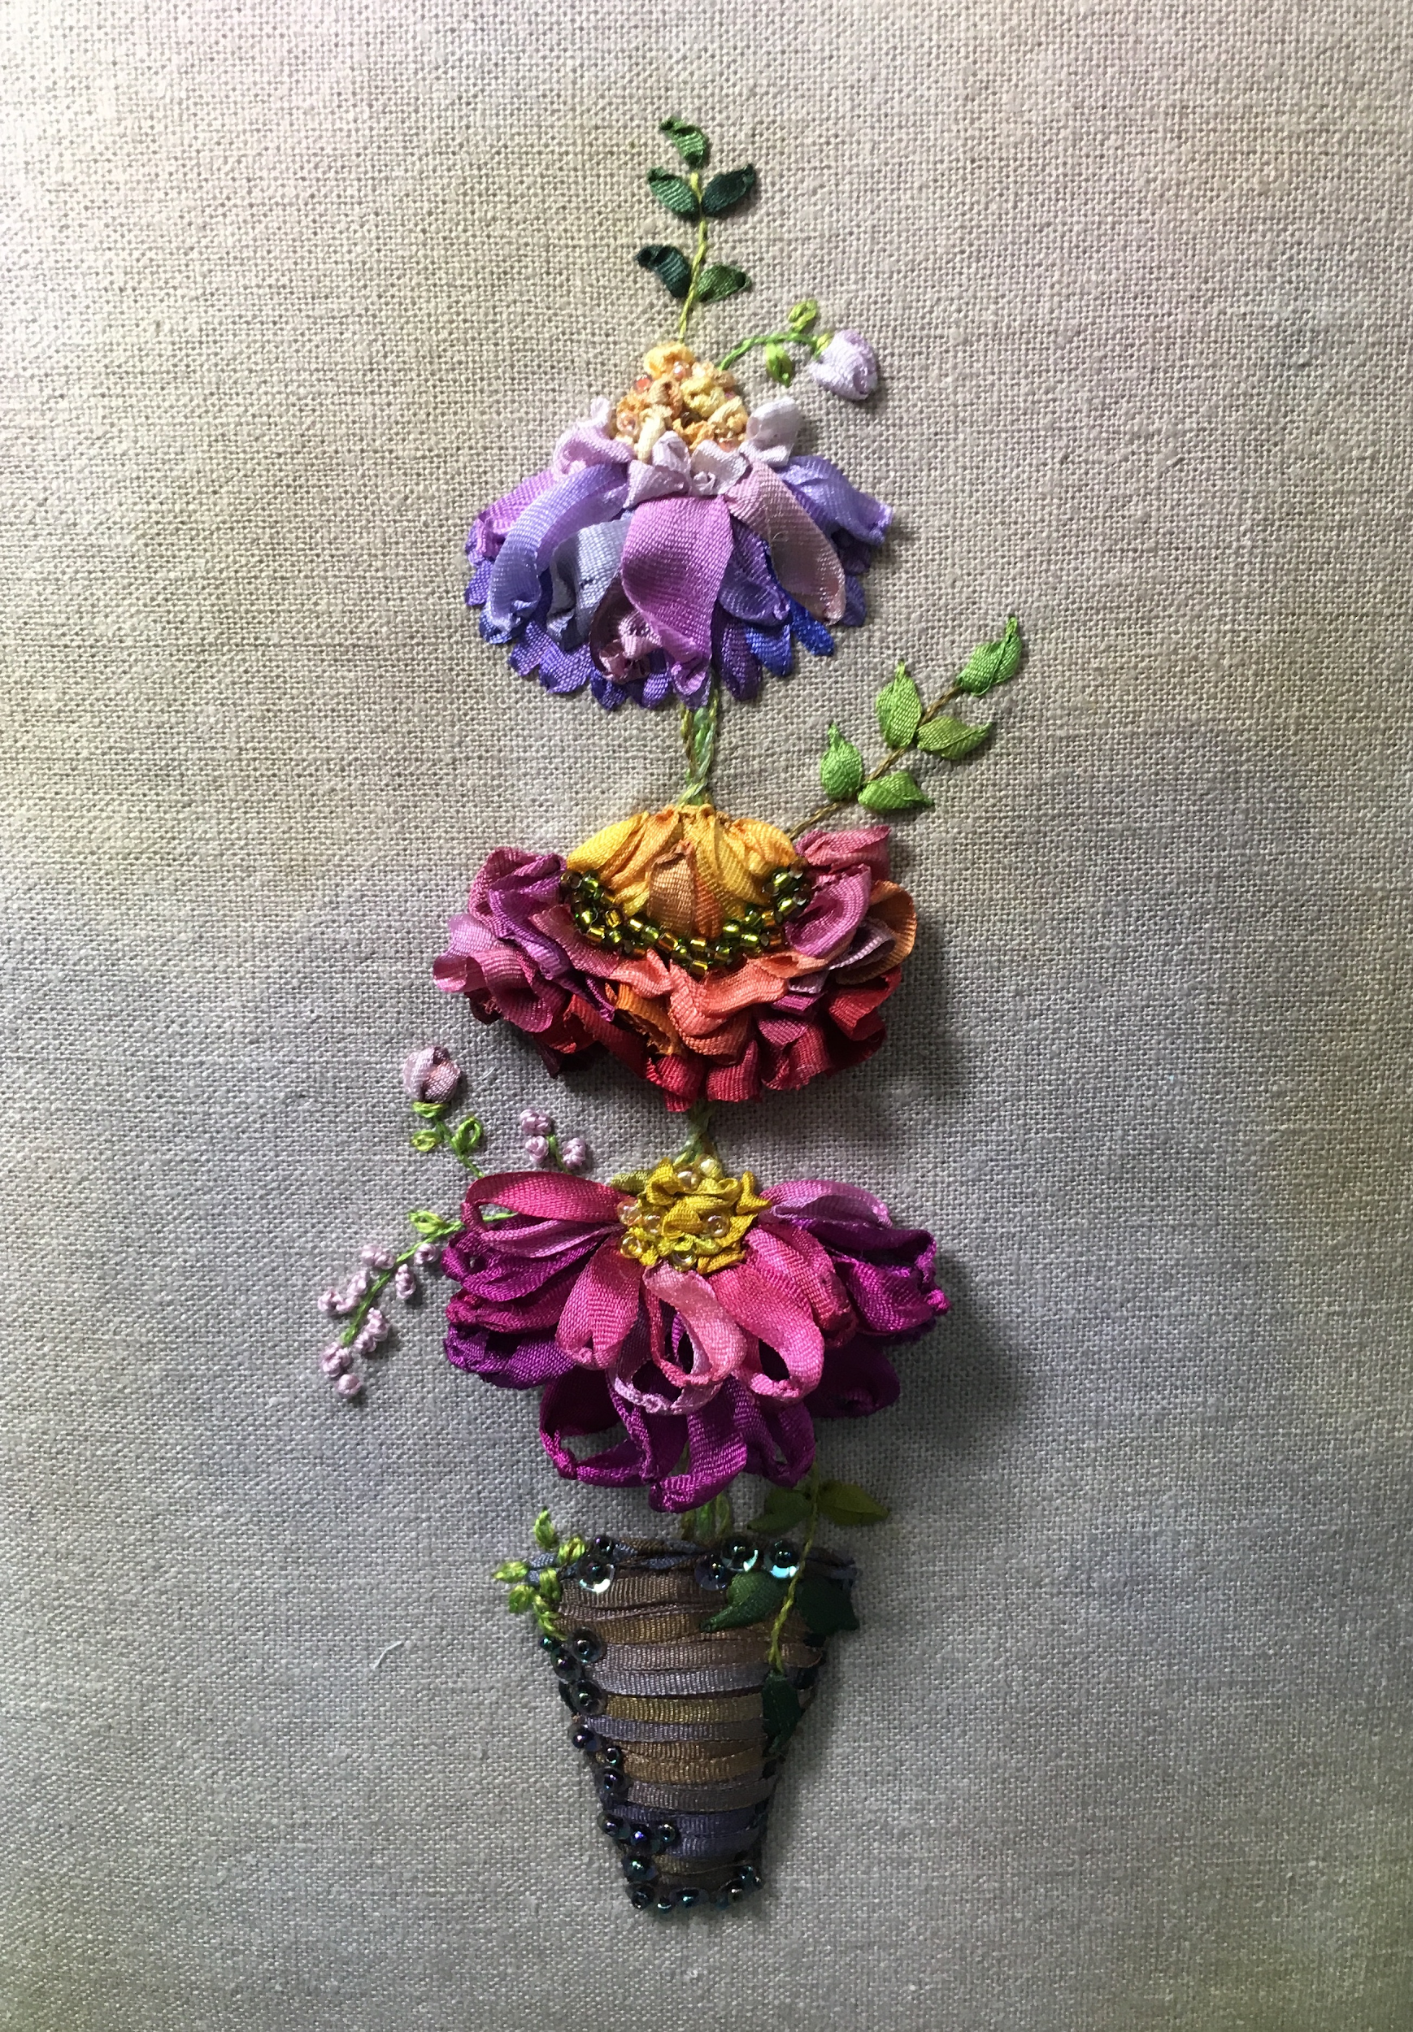
https://www.sfneedleworkanddesign.org/mary-jo-hineys-essential-stitches-and-nuances-of-ribbon-embroidery/

This image is an example of ribbon embroidery which became popular in Western fashion during the Renaissance. Frequently ribbon embroidery is of natural elements such as flowers, butterflies, etc.
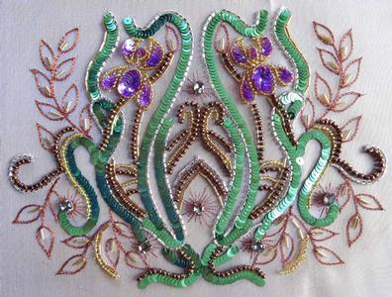
https://www.karentorrisibeading.com.au/classes/tambour-what-is-tambour

This image is an example of tambour embroidery, which originated in South Asia but migrated to France in the late 18th century. Each bead is individually stitched onto the garment.

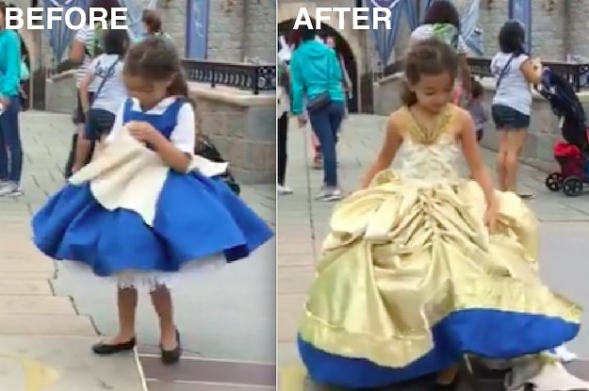
https://www.buzzfeed.com/alisoncaporimo/crafty-dads-forever

This image is the before and after for a transformation dress for Belle from Beauty and the Beast. The transformation occurs by removing the bodice and the hem of the yellow skirt falling from being secured to the hem of the bodice.

