Name/Date: _______________________________________________________
Sound Wave Notes
https://www.ducksters.com/science/sound101.php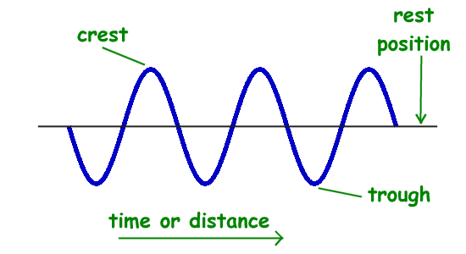
Properties of Waves
There are many properties that scientists use to describe waves. They include amplitude, frequency, period, wavelength, speed, and phase. Each of these properties is described in more detail below.
Graphing a Wave
When drawing a wave or looking at a wave on a graph, we draw the wave as a snapshot in time. The vertical axis is the amplitude of the wave while the horizontal axis can be either distance or time.
In this picture you can see that the highest point on the graph of the wave is called the crest and the lowest point is called the trough. The line through the center of the wave is the resting position of the medium if there was no wave passing through.
We can determine a number of wave properties from the graph.
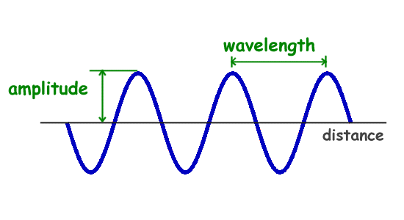
Amplitude
The amplitude of a wave is a measure of the displacement of the wave from its rest position. The amplitude is shown on the graph. Amplitude is generally calculated by looking on a graph of a wave and measuring the height of the wave from the resting position.
The amplitude is a measure of the strength or intensity of the wave. For example, when looking at a sound wave, the amplitude will measure the loudness of the sound. The energy of the wave also varies in direct proportion to the amplitude of the wave.
Wavelength
The wavelength of a wave is the distance between two corresponding points on back-to-back cycles of a wave. This can be measured between two crests of a wave or two troughs of a wave. The wavelength is usually represented in physics by the Greek letter lambda (λ).
Frequency and Period
The frequency of a wave is the number of times per second that the wave cycles. Frequency is measured in Hertz or cycles per second. The frequency is often represented by the lower case "f."
The period of the wave is the time between wave crests. The period is measured in time units such as seconds. The period is usually represented by the upper case "T."

Speed or Velocity of a Wave
Another important property of a wave is the speed of propagation. This is how fast the disturbance of the wave is moving. The speed of mechanical waves depends on the medium that the wave is traveling through. For example, sound will travel at a different speed in water than in air.
The velocity of a wave is usually represented by the letter "v." The velocity can be calculated by multiplying the frequency by the wavelength.

velocity = frequency * wavelength
or
v = f * λ

Sound is a vibration, or wave, that travels through matter (solid, liquid, or gas) and can be heard.
How does sound move or propagate?
The vibration is started by some mechanical movement, such as someone plucking a guitar string or knocking on a door. This causes a vibration on the molecules next to the mechanical event (i.e. where your hand hit the door when knocking). When these molecules vibrate, they in turn cause the molecules around them to vibrate. The vibration will spread from molecule to molecule causing the sound to travel.
Sound must travel through matter because it needs the vibration of molecules to propagate. Because outer space is a vacuum with no matter, it's very quiet. The matter that transports the sound is called the medium.
Mechanical Waves
One important characteristic of sound waves is that they are mechanical waves. This means that they travel through a medium. Sound waves can travel through all sorts of mediums. Normally, we hear sound waves that have traveled through air, but sound can also travel through water, wood, the Earth, and many other substances. Sound cannot travel through a vacuum like outer space, however.
The source of sound waves is something vibrating. This vibration causes a disturbance in the molecules around the source. The energy of the wave is transferred from molecule to molecule within the medium.
Longitudinal Waves
Another characteristic of sound waves is that they are longitudinal waves. This means that the disturbance of the wave travels in the same direction as the wave. As the molecules vibrate and transfer energy to each other they cause a wave that moves in the direction of the vibration.
The longitudinal characteristic of sound waves can be seen the picture below. Here you can see how the molecules move in a left to right motion causing the wave and the disturbance to move in the same direction. In some areas of the wave the molecules get bunched together. This is called compression. In other areas the molecules become spread out. This is called rarefaction.
What is the wavelength of a sound wave?
We studied how the wavelength of a transverse wave is measured from crest to crest or trough to trough. This is fairly easy to see when looking at a graph. However, sound waves are different as they are longitudinal. To determine the wavelength of a sound wave you measure from compression to compression or rarefaction to rarefaction.
Pressure Waves
Sound waves can also be thought of as pressure waves. This is because the compressions and rarefactions that move through sound waves have different pressures. The compressions are areas of high pressure while the rarefactions are areas of low pressure.
What is the amplitude of a sound wave?
Sometimes you will see a graph of a sound wave that looks like a sine wave (see below). This is different from the graph of a transverse wave. The peaks and valleys of this wave graph the changes in pressure that occur in the wave. From this graph we can determine the amplitude of the sound wave. The amplitude is the peak of the compression or rarefaction on the graph.
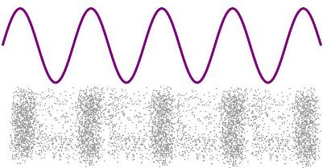

Frequencies
An important measurement of sound is the frequency. This is how fast the sound wave is oscillating. This is different than how fast the wave travels through the medium. Frequency is measured in hertz. The faster the sound wave oscillates the higher pitch it will have. For example, on a guitar a big heavy string will vibrate slowly and create a low sound or pitch. A thinner lighter string will vibrate faster and create a high sound or pitch. See musical notes for more on what makes up a musical note.
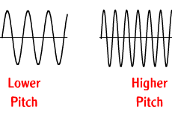
Talking
Not only is hearing sound important, but we also create sound to communicate. The process of making precise sounds for speech is very complex and involves many parts of the body working together. Sounds are made by our vocal cords vibrating in our throat. This way we can adjust our volume and our pitch. We also use our lungs to force air past our vocal cords and start them vibrating. We use our mouth and tongue as well to help form specific sounds. It's truly amazing we can make a sound let alone the complex system of sounds humans can create to communicate with speech.
Acoustics
Acoustics is the study of how sound travels. It's important in controlling how sound behaves and is used in designing buildings like auditoriums, theaters, and libraries. In some cases acoustics is used to help sound travel. For example, in a large concert hall, acoustics helps so that everyone in the building, even the back seat, can hear the music. In a library, acoustic design would help to keep sound from traveling to help the library stay quiet.
There are two main ways to control acoustics:
Reverberation - reverberation is how sounds bounce off things. Typically a "loud" room would be one where the sound is reverberating off the walls and floors. Some materials echo sounds better than others. For example, a tile floor will reverberate a sound better than a carpeted floor (which would absorb the sound).
Absorption - The opposite of reverberation, items that absorb sound don't reflect the vibrations. Soft items such as carpet and curtains will help to absorb sound and make a room quieter.
The Doppler Effect
If you are standing still and a car drives past you, the frequency of the sound will change as the car passes you. This is called the Doppler Effect. The sound pitch will be higher as the car is coming towards you and then lower as the car moves away. The sound the car is producing is not changing. Its frequency is the same. However, as the car is traveling towards you the speed of the car is causing the sound waves to hit your ear faster or at a higher frequency than the car is making them. Once the car passes you, the sound waves are actually reaching your ear at a lower frequency. The Doppler Effect is named for scientist Christian Doppler who discovered it in 1842.

