Name/Date: ____________________________________
Sound and Lighting Packet – Proficient

Now that we have finished our lighting plots, you need to understand how we power and control those fixtures.
The path of electricity from the fixture to the light board (or lighting console) is called a “Stage Circuit” or “Circuit”. This is illustrated below in the simplified diagram.

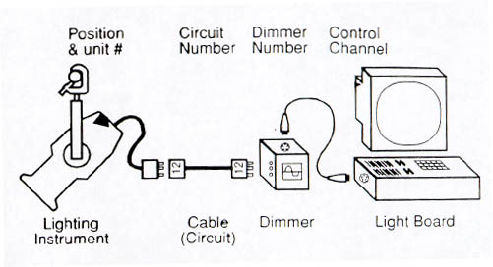

Although very different fields, lighting and sound have a lot in common when it comes to how they operate. Sounds follows a signal path rather than a circuit but uses devices that preform similar tasks.

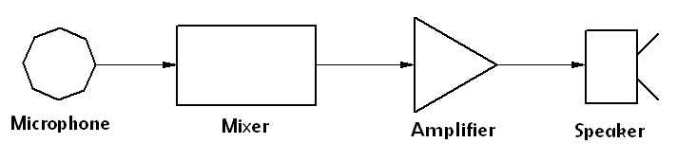

PREFACE
A lot of people ask how lighting works in respect to audio and the answer is fairly simple: In audio you use a mixer to set the levels of your inputs and then send those levels to the amplifier (s).
In lighting, you have a control console/board which acts like a mixer and sends output information to the dimmer (s).
Amplifiers power speakers. (Sound)
Dimmers power fixtures. (Light)
Speakers output sound. (Sound)
Fixtures output light. (Light)

The following page contains a diagram that further explains this relationship and will visually reinforce this theory.
The important thing to remember is that there are three major parts to a lighting system:
1. Control Console
2. Dimmers
3. Fixtures

1. Control Console
As stated above, a lighting console is a lot like a mixing console in the fact that you are setting levels for each channel. The difference on a lighting console is that the operator (often called lighting programmer or designer) is setting levels for a dimmer channel (which is wired to fixtures/lamps). You can think of a channel on a control console as a (dimmer) slide pot that allows you to run a group of lights from 0-100%.

2. Dimmers
Dimmers are to lights what amplifiers are to sound. Power distribution devices that relay high voltage power. The major difference is that dimmers drive fixtures or lamps instead of speakers. The other reason we use dimmers is that a lamp that is set to a level less than 100% will generate noise (buzz). Dimmers use inductors, or chokes, to filter this noise. The bigger the inductor, or choke, the quieter the dimmer.

3. Fixtures
Fixtures are wired to dimmer channels via different types of connectors. Some use plugs like U-Ground (Edison), Twist Locks or Stage Pins and others are hard wired using a terminal strip (primarily in installations).

“Where a sound mixer controls the amplifier that drives the speaker, the lighting console controls
the dimmer that drives the lamp”.
Console........Dimmer........Fixture
Mixer................Powered Speaker

TERMINOLOGY:
Before you can understand patching, you must first understand channels, dimmers, addresses, and circuits.
Channel:
A control path that allows the console to vary the output level of one or more dimmers or other devices. The channel can be physical (controlled by a button, switch or slider) or virtual, (controlled by a numeric keypad). More properly referred to as "control channels," to differentiate them from "DMX channels" (see "Addresses," below).
Dimmer:
A device which regulates light intensity. Most dimmers do this by electronically controlling the electricity transmitted to the lamp. Fixtures with discharge lamps may have mechanical dimmers which regulate the amount of light by hiding it, similar to Venetian blinds. Electronic dimmers have maximum capacities; since a channel can control any number of dimmers, the capacity of a channel is limited only by the number of dimmers available to you. Each dimmer has an "address".

WHAT IS AN ADDRESS?
One of the first things you’ll have to do when you begin lighting is to address your fixtures.
An address is the location in the 512-channel universe that the DMX device begins. Often, this is referred to as the “start address” since it is the first address that a given fixture uses.

If you have a one-channel device, like a conventional channel on a dimmer, than you can address the fixtures one right after another. This would give you the first on address 1, the second on 2, etc.
Pretty simple.
However, if it is a multiple channel fixture, like an LED or moving light, you need to be sure and leave the total amount of channels the fixture takes open before patching the next fixture.
Not quite as simple!
So, if you have a 3-channel fixture starting at channel 28, the next open address would be address 31.
If you don’t do this, you’ll be trying to control one light, and another one may start doing something you did not expect!

PATCHING:
When we hang lights, we plug them into the most convenient – or least inconvenient – circuits, but when it comes time to set cues and run rehearsals and performances, it is usually easier to control lights with similar functions from adjacent channels. The process of connecting circuits, dimmers, and channels together in a manner that makes their operation logical and convenient is called "patching".

Types of Patching:
Hard patching:
This is the connection of circuits to dimmers (and, in early electronic control systems, dimmers to channels) physically, either through a "patch panel" (see photo) or by plugging cables directly into the dimmers. Hard patching is rarely done these days; most modern theatres are "dimmer-per-circuit", with each circuit permanently wired to a dimmer.
Soft patching:
This is a virtual connection (rather than a physical one) and is achieved by telling the computer – because that's what a modern control console is, a computer with a specialized interface – that every time a level is set for channel X, it's really the level for dimmers Y and Z.

LIGHTING CABLES:

EDISON
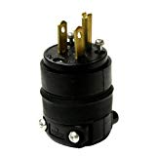
The most common type of power connector that we see in the entertainment industry is the Edison plug.
This is the 3-pronged general duty plug that you have on the walls in your home and everywhere else. It should only be used for 120v power, and is best for Non-Dim 120v power.
I know that some people try and use this plug for 208v power, especially with PowerCon inputs(see below). However, that is very dangerous and can electrocute people if something gets plugged into the wrong place. Don’t do it!
Like I mentioned above, the Edison connector can also be used for 120v dimmed power, and most small dimmer packs and racks feature this plug on the output.
Just be careful, because if you plug something that is not dimmable into a dimmer pack, you will likely burn out the power supply. Even if you park your dimmer at full, it still isn’t the same exact current as a straight wall-plug due to the dimmers electronics, so even doing that is a risk to gear and should be avoided.

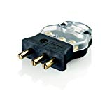
STAGE PIN (What we have at NWSA)
Our next most common plug is the flat plug known as a Stage Pin. Most commonly seen in theaters, it is often the standard 120v dimmed power plug and a great option for any installed venue. I really like putting dimmers on stage pins because you then know that no one can accidentally plug a non-dimmable item into a dimmer!
If you’ve been around stage lighting for awhile, you’ll probably know that stage pins don’t always plug together well, and that’s the reason why many people don’t like them. They’re either too loose and you have to tape them, or too tight and tough to get apart.
Thankfully, this has now changed. There is now an international standard for the exact dimensions of the Stage Pin plug, so any new Stage Pin plugs you buy should mate perfectly together. Hooray!

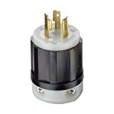
L620 TWISTLOCK
Most, if not all 208v moving lights and LED lighting fixtures and video walls use the L620 Twistlock. It is the production industry standard for 208v power.
So, if you own or rent moving lights or other fixtures that run on 208v power, this is the plug that you should use.
It’s important to note that electrically, this plug has 2 hots and a ground, but no neutral. The 2 hot legs use each other to complete the electrical circuit, so there’s no need for a neutral.

POWERCON BLUE AND WHITE
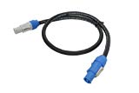
A lot of modern, auto-sensing moving lights and LED fixtures use a PowerCon input that will take 120v or 208v. This presents a problem when production companies buy all Edison to PowerCon cables for the inputs and then want to run the fixtures at 208v.
It is incredibly dangerous to use a 120v plug for 208v power! Even if you think all of your crew are paying attention and competent, a stagehand or volunteer help will plug something in and the gear will get fried, and they might too! Friends don’t let friends use Edison plugs on 208v power! Not only is the Edison plug not rated for 208v, it’s just plain dangerous.

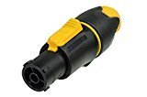
POWERCON TRUE1
The True1 is an update to the existing PowerCon connector that I believe will eventually replace the “old” PowerCon completely. Neutrik has engineered this plug to be both waterproof and able to make/break while the power is on.
This is a significant improvement over the old Blue/White PowerCon’s, and for that reason, I am excited to see it take over!

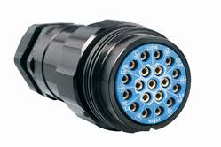
SOCAPEX MULTIPIN CABLE
Socapex is the amazing cable that we use in the lighting world to carry 6 circuits of power inside 1 multipin cable.
Socapex features 19 pins, an all-metal exterior and locking threads to keep the connectors together. The locking threads mean that junctions between 2 cables can be in the air, which is very helpful!
In the lighting world, we have what are called 6-light bars that have an actual Socapex plug on them and then distributes the 6 circuits to the individual lights.
When using these bars, you can simply go from the dimmer rack to the bar and plug in Socapex on both ends.
When using individual lights, you can use a Socapex fan out, also known as a break out. This cord takes the Socapex end and turns it into 6 circuits of Edison, Stage Pin, or L620.
Like PowerCon, Socapex cable can be used for both 120v and 208v power.

This is where you need to be careful, and know what you’re doing. Always have good labels on your Socapex, and never, ever mate a 120v fixture to a 208v plug. I know a technician who went into the hospital with 3rd degree electrical burns on his hand because he was hurrying and messed up. He could have died, but he was fortunate.
As long as you keep that safety tip in your head, work carefully and never make an electrical connection you don’t understand, Socapex is a great tool to save you a ton of time and cable mess! FYI, “Soco” is the shorthand name for Socapex, and that’s what you’ll hear it called most of the time.

DATA CABLE

Used to transmit information for color, movement, etc. In led or smart instruments. Needed in addition to power cable for instruments that have additional capabilities other than turning on and off

WHAT IS DMX 512?
DMX512 stands for digital multiplex 512. This means that 512 channels are controlled digitally through 1 data cable.
A channel is 1 set of 255 steps that are assigned to control attributes in each light. This may be a color like red, green or blue, and intensity, strobe, pan/tilt or other attributes.
This is pretty incredible if you remember some old analog control systems where you had 1 pair of wires for each channel of the console!
I don’t miss those one bit!
Data is sent down this line via pulses of electricity from a lighting console, into your fixtures that are usually “daisy chained” together. This means that you plug the initial DMX cable into the first fixture, the “OUT” of the first fixture into the second fixture, etc, up to 32 fixtures maximum (more on that below).
DMX is not manufacturer specific. DMX-controlled lights from any manufacturer can be controlled by any DMX console – even if that console is made by someone else.

WHAT IS A UNIVERSE?
On the back of your lighting console, you may see writing that says “Universe 1”, “Universe 2”, or “DMX A”, “DMX B”, etc, but what in the world is that?
A universe of DMX is 512 channels of output from the console.
When you finish out the first universe of 512, you move over to the 2nd universe and restart at address 1. Some consoles, however, will default to numbering the 2nd universe at channel 513-1024.
Universes can’t be combined together, and each universe needs its own DMX cable run.
Many simple lighting consoles only have 1 universe, so if you are just starting out, you probably don’t need a great understanding of DMX 512 universes.

ETHERNET AND ETHERCON ARTNET & OTHER NETS
The last type of data cable you may see “out in the wild” is the good ‘ole Ethernet cable. This is the common cable that delivers internet to your computer, and has non-internet uses in the entertainment business.
The most common non-internet data you’ll see running down Ethernet is Art-Net or sACN. This allows you to send large amounts of DMX universes of data shooting down 1 cable, and gets very useful when you are working with large lighting rigs!

Questions:
- What are the types of lighting instruments you have learned about so far in class?
- Which of those instruments would require a Stage Pin connector and which would require a PowerCon Connector for power?
- When we are using lighting instruments in our theatre, we plug them into what to start the Circuit Path?
- Why do we need to use a “Patch” in order to control the lights from our board?
- Why would you need to use a second universe?
- What might you call a cable that split into multiple ends to power multiple instruments?
- LED Instruments Require Data and Power, what type of cables would you need to use to make your LED fixture function?
- What is a “Daisy Chain”?
- Why would I want to have multiple dimmers/addresses assigned to one channel on the lighting board?
- Stage Pin Cable : Socapex Cable :: DMX Cable : ________________________

