How to Draft in Adobe Illustrator
When you first open Adobe Illustrator this is what will appear on your screen.
To create a new document, move your cursor to the upper lefthand corner and click on the button labeled “File.” From there, you have the choice to create a new document or to open an existing file. In this circumstance click New.
When creating a new document, ensure that the measurements are in inches, the page is letter sized, and that you name your document. Click Ok when you are finished. 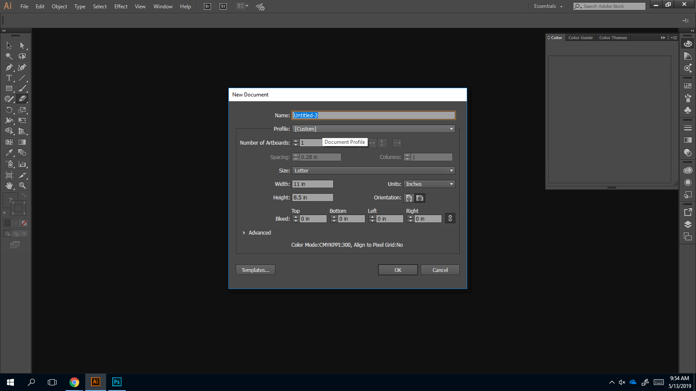
The first thing you must do when setting up your Illustrator document, move your cursor to the top of the screen and onto the tab labeled View. From there, scroll down to the tab labeled Rulers and then to Show Rulers. By doing this, you are ensuring that you will be able to measure correctly while making your draft. 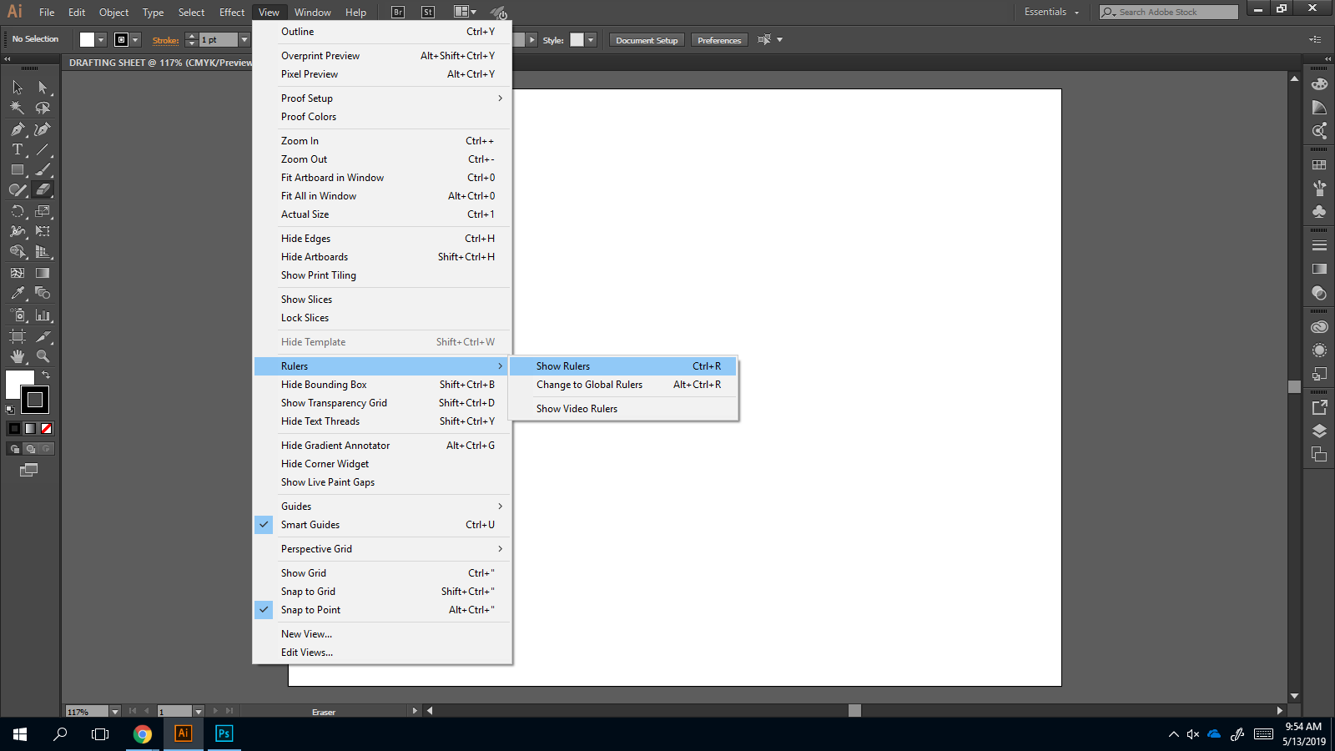WHen creating a digital draft, the setup is exactly like that of a hand draft. To set up your borders, move your cursor to the left hand toolbar and click the icon with a rectangle. Click on the middle of the page to bring up the rectangle box. A piece of paper is 8.5”x11” so when entering the size of your rectangle, you have to subtract the width of the border which is ¼” on each side. Thus, the size of the rectangle is 8”x 10.5”. 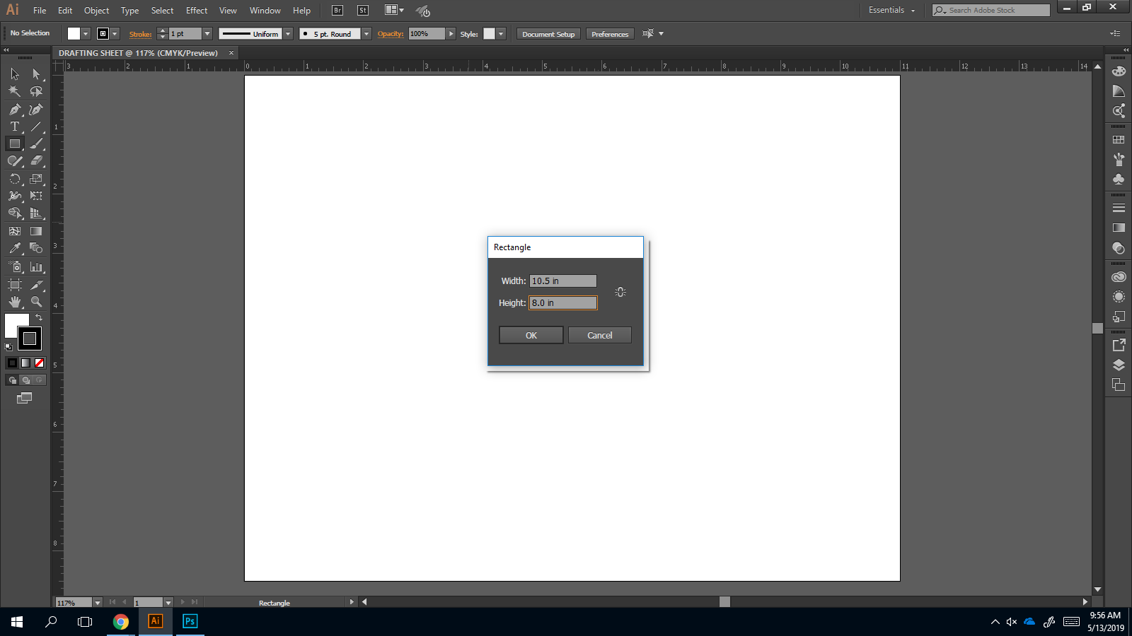Once you click Ok to create your rectangle, it will appear on screen. However, the rectangle is filled with white, we need the rectangle to be clear for our drafting purposes.
To change this, move your cursor to the left hand toolbar. Click the white box to move it to the front. Then, click one of the three boxes below it with the white background and a red line through it. This will change the fill of the box from white to clear.
Now, to move your rectangle into place on the drafting sheet you need to select the selection tool icon. This is the black mouse icon in upper lefthand corner of the tool bar.
Now that the selection tool is located, click on the rectangle and drag it into the middle of the page. It should be clear when the rectangle is properly aligned when a pink x appears in the middle of the screen indicating that it is centered on the page.
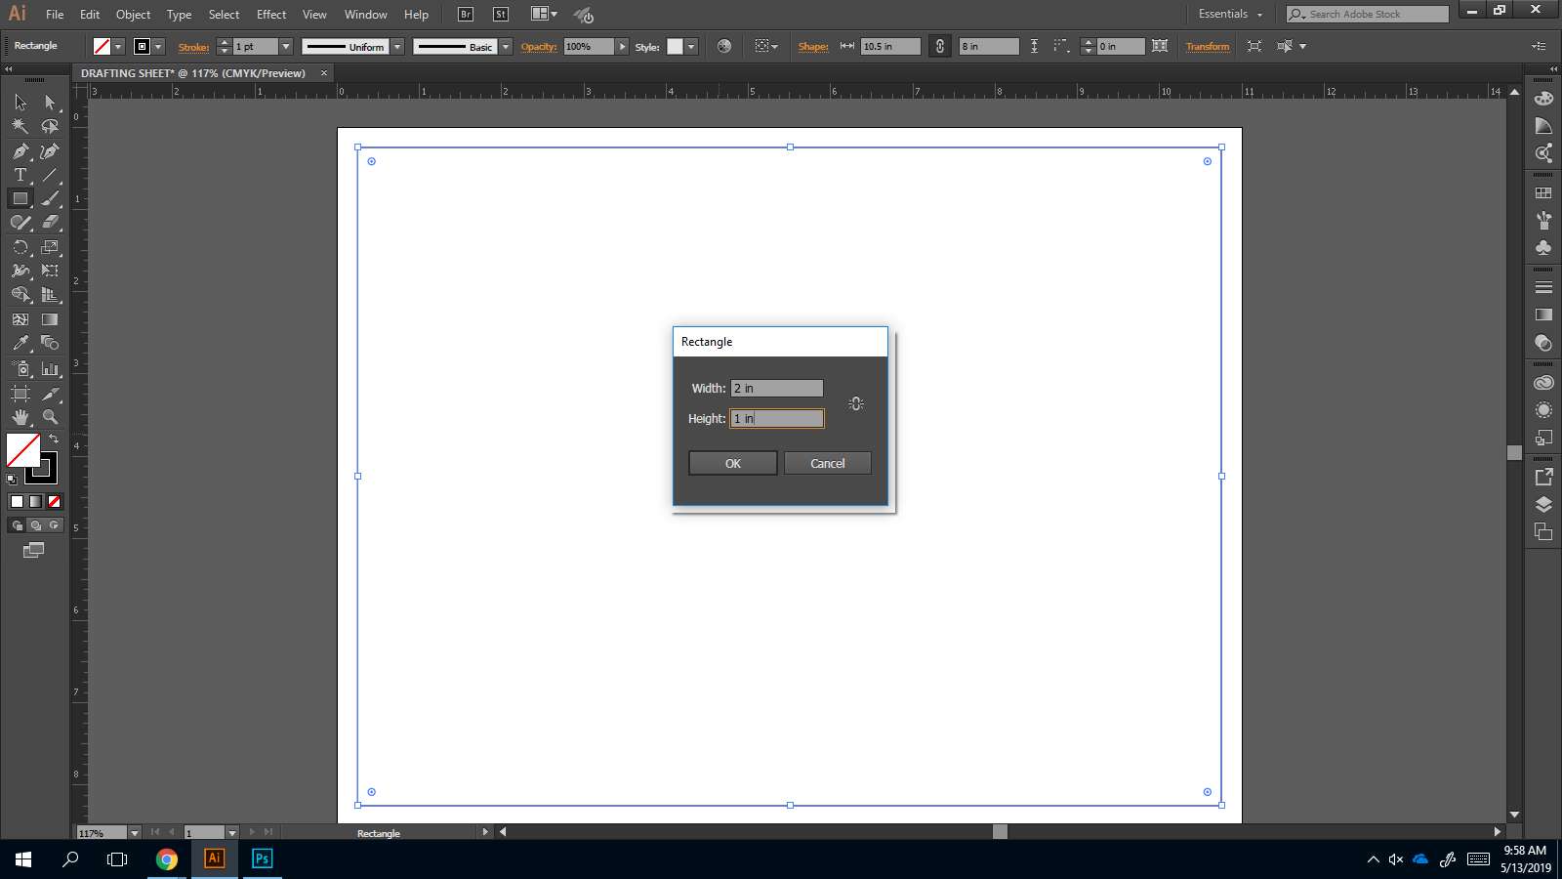
To create your title block, you will follow the same procedures you used to create your border. Click the icon on the toolbar that shows a box and then click on the screen. When the rectangle box appears, enter the dimensions for your title block. When you are finished, click Ok.
To include text in your title block, move your icon to the left hand toolbar and select the icon that displays a ‘T.’ Then, move your cursor back to the title block and click to create a new textbox. Then, enter your desired text.
Congrats! You have successfully set up your drafting sheet in Adobe Illustrator. Using what you learned, you should be able to complete basic and intermediate drafting using this software.

