Name/Date: ____________________________________________
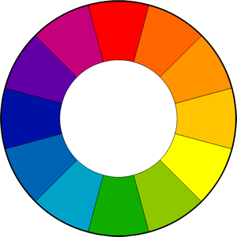
Beginning Color Theory in Lighting:
SUBTRACTIVE COLOR THEORY –
This is the color theory we are familiar with and have learned since Kindergarten. This theory applies to pigment, such as paint, dyes, etc.
All the primary colors mixed together make BLACK. Therefore, we assume the presence of all color is black.
However, this changes significantly in lighting.
ADDITIVE COLOR THEORY – RGB LIGHTING
The first method of coloring light is the additive theory a method that presents itself primarily in RGB (Red, Green and Blue) LED lighting. RGB are the primary colors for this lighting theory. They combine to create Cyan, Magenta and Yellow are the secondary colors.
The presence of all color in light = WHITE. Think about a prism that you might hang in your window!
LED Instruments can also include an amber and/or white LED alongside of the RGB to give you some more options and flexibility.
However, a RGBW or RBWA LED fixture may not be able to achieve the same colors based on the differences in their LED color mixing capabilities.
Additive colors work by fading up and down the colored LED’s or “Light Emitting Diodes” in order to mix the desired color.
The additive color theory also works with conventional lights that are gelled, and you can mix colors when pointing 2 lights at the same object from about the same position. These Gels filter out the other wavelengths that you do not want to see.
For instance, if you place a blue gel in an incandescent Source 4, the gel will filter out all the light except for blue.
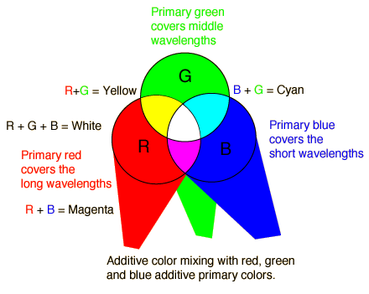
RGB Color Mixes
- Red at Full + Green at Full = Yellow
- Red at Full + Blue at Full = Magenta
- Green at Full + Blue at Full = Cyan
- Red at Full + Green at Full + Blue at Full = White

Questions:
  - Why can’t you layer gels on an incandescent instrument to achieve a new color? You may use diagrams to explain.
  - Please explain why certain LED lighting fixtures would not achieve the same color, even if you choose the same color on the light board’s. Consider Diodes…….
  - Please match the two color theories to their correct definition:
Additive Color Theory - _____________
Subtractive Color Theory- ____________
  - Pigment; Primary colors – Red, Yellow and Blue
  - Pigment; Primary colors – Cyan, Magenta and Yellow
  - Lighting; Primary colors – Red, Green and Blue
  - Lighting; Primary colors – Cyan, Magenta and Yellow

